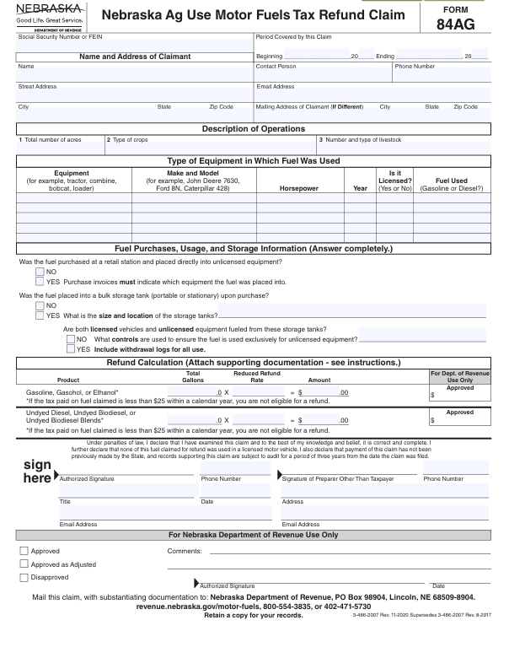
EO 26-21
Dyed Diesel

